A Project Report

*On*

TICKETONIC – Online Movie Ticket Booking System

*By*

Himanshu Agrawal (307002)

Atul Anand (307012)

Nikhil Baad (307016)

Swapnil Baad (307017)

*Under the guidance of*

Prof. K. B. Sadafale



**Department of Information Technology**

**Sinhgad College of Engineering**

**SAVITRIBAI PHULE PUNE UNIVERSITY**

**2017-2018**

|  |  |
| --- | --- |
| Sinhgad Technical Education Society,  Department of Information Technology  Sinhgad College of Engineering , Pune-41 |  |

Date:

**CERTIFICATE**

This is to certify that,

Himanshu Agrawal (307002)

Atul Anand (307012)

Nikhil Baad (307016)

Swapnil Baad (307017)

of class TE - I.T. have successfully completed their project work on “TICKETONIC – Online Movie Ticket Booking System’’ at SINHGAD COLLEGE OF ENGINEERING in the partial fulfillment of the Graduate Degree course in T.E at the Department of Information Technology, in the academic Year 2017-2018, Semester – I as prescribed by the Savitribai Phule Pune University.

Prof. K. B. Sadafale Prof. G. R. Pathak

Guide Head of the Department

(Department of Information Technology)

**ACKNOWLEDGEMENT**

We feel great pleasure in expressing our deepest sense of gratitude and sincere thanks to our guide **Prof. K.B. Sadafale** for his valuable guidance during the Project work, without which it would have been very difficult task. We have no words to express our sincere thanks for valuable guidance, extreme assistance and cooperation extended to all the **Staff Members** of our department.

This acknowledgement would be incomplete without expressing our special thanks to **Prof. G. R. Pathak,** Head of the Department (Information Technology) for his support during the work.

We would also like to extend our heartfelt gratitude to our **Principal, Dr. S. D. Lokhande** who provided a lot of valuable support, mostly being behind the veils of college bureaucracy.

Last but not least we would like to thank all the Teaching, Non- Teaching staff members of our department, our parent and our colleagues those who helped us directly or indirectly for completing of this Project successfully.

Himanshu Agrawal

Atul Anand

Nikhil Baad

Swapnil Baad

**CONTENTS**

1. **TITLE OF THE PROJECT**
2. **ABSTRACT**
3. **INTRODUCTION**

* Problem definition

1. **SCOPE**
2. **SPECIFIC REQUIRMENTS**

* Hardware Interface
* Software Interface

1. **THEORY OF SOFTWARES USED**

* Java (JDK)
* MYSQL

1. **DATABASE FORMAT**
2. **ER DIAGRAM**
3. **OUTPUT SCREEN (GUI)**
4. **SAMPLE CODE**
5. **CONCLUSION**
6. **REFERENCES**

**Chapter - 1**

**TITLE OF THE PROJECT**

The title of this project is **“TICKETONIC”**, an online movie ticket booking system.

**Chapter - 2**

**ABSTRACT**

Our project basically manages the ticket booking process of theatres, providing an interface to the user to book movie tickets in a more easy way. At the front end we have used JAVA (JDK) and at the back end My SQL server. The project proceeds through a sequence of well-designed forms provided with validations to ensure consistency, reliability and most importantly correctness of information fed into the database. The other important objective of this program is to track all account details particularly no of tickets sold for each show in each theater.

**Chapter - 3**

**INTRODUCTION**

**Problem Definition**

Movie-going is one of the most popular out-of-home cultural activities, affecting a series of social, economic and cultural phenomena in modern societies. Movies are considered to be an integral part of cities and they contribute to the definition of a local geography and identity. They also contribute to the preservation of the collective memory, since they constitute a significant social and cultural practice linked to a specific place, which acts as a common reference or landmark for many individuals.

Through this project we present a comprehensive solution for online ticket booking for movies sitting at home or anywhere else at the tip of hand with quite ease. TICKETONIC, an online movie ticket booking software that is easy to understand, easy to use and offers the simplicity of fast point-and-click service to the customers.

This powerful software program is specifically designed for theater owners, to sell movie tickets online. This intuitive visual interface makes day-to-day aspects of selling, exchanging, refunding, and reporting fast and easy for both the user and administrators. Theater management controls all back-end functionalities like movie details, tickets rate, show time, customer information and sales history saved in a database, etc. Theater admin manages the report details like counter wise report, daily, weekly, monthly report and movie report etc.

**Limitations**

* This project is meant for maximum of 4 theatres. But as per the requirement the changes can be done to accommodate more theatres.
* The number of movies can be maximum 12. More movies can be added with simple changes.
* In a theatre at most 3 shows can be scheduled on a specific day.
* In this system, user can book tickets in advance for two days only.
* At a time, a user can book maximum of 10 tickets for a show.
* Any theatre is having only one auditorium hall and number of seats is fixed to 40.

**Chapter - 4**

**SCOPE**

This project will have wide scope as nowadays in every city there are humongous number of theatres and multiplexes. This project will certainly be helpful in management of theatres, shows, and movies.

It will help in perfect management of the data and its retrieval along with manipulation. In a very short time, the collection will be obvious, simple and sensible. It will help the theatre managers to know the management of previous days perfectly and vividly. It also helps in current process of management. It will be also reduced the cost of collecting the management & collection procedure will go on smoothly.

The present project has been developed to meet the aspirations indicated in the modern age. An attempt has been made through this project to do all work ease & fast. It provide current add, Update, Find & Delete all facilities to accomplish the desired objectives. The facilities included in this project and the suggested activities have been organized to impart knowledge & develop skill in theatre management system.

**Chapter - 5**

**SPECIFIC REQUIREMENTS**

**Hardware Interface**

Processor :Intel Core 2 duo or above

RAM : 1 GB or more

Hard disk : 80 GB or more

Monitor : 15” display

Mouse : Normal

Keyboard : Normal

**Software Interface**

Front End : Java (JDK)

Back End : MySQL

Softwares Used : Netbeans, Adobe Photoshop

Platform : Windows 8.0 or above

**Chapter - 6**

**THEORY OF SOFTWARES USED**

**Java (JDK)**

The **Java Development Kit** (**JDK**) is an implementation of either one of the Java Platform, Standard Edition, Java Platform, Enterprise Edition, or Java Platform, Micro Edition platforms released by Oracle Corporation in the form of a binary product aimed at Java developers on Solaris, Linux, mac OS or Windows. The JDK includes a private JVM and a few other resources to finish the development of a Java Application. Since the introduction of the Java platform, it has been by far the most widely used Software Development Kit (SDK). On 17 November 2006, Sun announced that they would release it under the GNU General Public License (GPL), thus making it free software. This happened in large part on 8 May 2007, when Sun contributed the source code to the Open JDK.

**MySQL**

**MySQL** an open-source relational database management system(RDBMS). Its name is a combination of "My", the name of co-founder Michael Widenius's daughter, and "SQL", the abbreviation for Structured Query Language. The MySQL development project has made its source code available under the terms of the GNU General Public License, as well as under a variety of proprietary agreements. MySQL was owned and sponsored by a single for-profit firm, the Swedish company MySQL AB, now owned by Oracle Corporation. For proprietary use, several paid editions are available, and offer additional functionality.

**Chapter - 7**

**DATABASE FORMAT**

mysql> desc user;

+-------------+-------------+------+-----+---------+-------+

| Field | Type | Null | Key | Default | Extra |

+-------------+-------------+------+-----+---------+-------+

| user_name | varchar(50) | NO | PRI | NULL | |

| user_emid | varchar(50) | YES | | NULL | |

| user_pwd | char(32) | YES | | NULL | |

| mob_no | varchar(50) | YES | | NULL | |

| user_status | int(11) | YES | | NULL | |

+-------------+-------------+------+-----+---------+-------+

5 rows in set (0.09 sec)

mysql> desc theatre;

+---------+-------------+------+-----+---------+-------+

| Field | Type | Null | Key | Default | Extra |

+---------+-------------+------+-----+---------+-------+

| th_id | int(11) | NO | PRI | NULL | |

| th_name | varchar(50) | YES | | NULL | |

| area | varchar(50) | YES | | NULL | |

+---------+-------------+------+-----+---------+-------+

3 rows in set (0.08 sec)

mysql> desc movie;

+----------+--------------+------+-----+---------+-------+

| Field | Type | Null | Key | Default | Extra |

+----------+--------------+------+-----+---------+-------+

| mov_id | int(11) | NO | PRI | NULL | |

| mov_name | varchar(50) | YES | | NULL | |

| descr | varchar(50) | YES | | NULL | |

| rating | int(11) | YES | | NULL | |

| synopsis | varchar(200) | YES | | NULL | |

+----------+--------------+------+-----+---------+-------+

5 rows in set (0.02 sec)

mysql> desc schedule;

+--------+---------+------+-----+---------+-------+

| Field | Type | Null | Key | Default | Extra |

+--------+---------+------+-----+---------+-------+

| sch_id | int(11) | NO | PRI | NULL | |

| th_id | int(11) | YES | MUL | NULL | |

| mov_id | int(11) | YES | MUL | NULL | |

| date | date | YES | | NULL | |

| start | time | YES | | NULL | |

| end | time | YES | | NULL | |

+--------+---------+------+-----+---------+-------+

6 rows in set (0.07 sec)

mysql> desc seat_list;

+--------+-------------+------+-----+---------+-------+

| Field | Type | Null | Key | Default | Extra |

+--------+-------------+------+-----+---------+-------+

| sch_id | int(11) | NO | PRI | NULL | |

| row_no | varchar(50) | NO | PRI | NULL | |

| col_no | int(11) | NO | PRI | NULL | |

| status | int(11) | YES | | NULL | |

+--------+-------------+------+-----+---------+-------+

4 rows in set (0.08 sec)

mysql> desc payment;

+-----------+-------------+------+-----+---------+-------+

| Field | Type | Null | Key | Default | Extra |

+-----------+-------------+------+-----+---------+-------+

| p_id | int(11) | NO | PRI | NULL | |

| user_name | varchar(50) | YES | MUL | NULL | |

| card_no | varchar(50) | YES | | NULL | |

| amount | int(11) | YES | | NULL | |

+-----------+-------------+------+-----+---------+-------+

4 rows in set (0.02 sec)

mysql> desc reservation;

+---------+-------------+------+-----+---------+-------+

| Field | Type | Null | Key | Default | Extra |

+---------+-------------+------+-----+---------+-------+

| tckt_id | int(11) | NO | PRI | NULL | |

| sch_id | int(11) | YES | MUL | NULL | |

| row_no | varchar(50) | YES | | NULL | |

| col_no | int(11) | YES | | NULL | |

| p_id | int(11) | YES | MUL | NULL | |

+---------+-------------+------+-----+---------+-------+

5 rows in set (0.06 sec)

mysql> desc admin;

+--------------+-------------+------+-----+---------+-------+

| Field | Type | Null | Key | Default | Extra |

+--------------+-------------+------+-----+---------+-------+

| admin_name | varchar(50) | NO | PRI | NULL | |

| admin_pwd | char(32) | YES | | NULL | |

| admin_status | int(11) | YES | | NULL | |

+--------------+-------------+------+-----+---------+-------+

3 rows in set (0.12 sec)

**Chapter - 8**

**ER DIAGRAM**

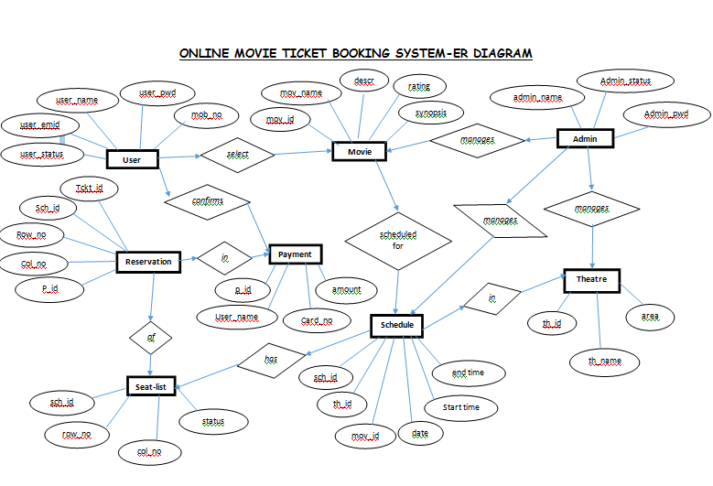

Fig 8.1 E R Diagram

**Chapter - 9**

**OUTPUT SCREEN (GUI)**

* **Frontpage Frame :**

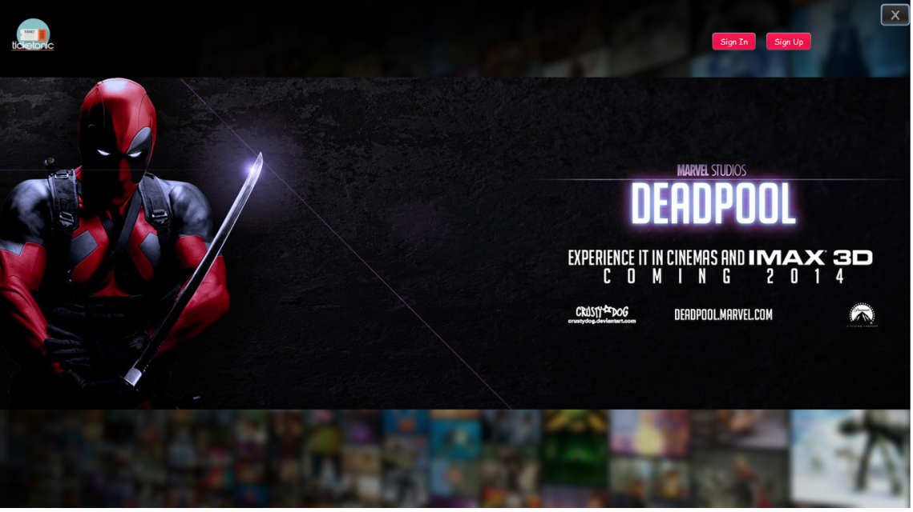

Fig 9.1 Front page

* **User Signin Frame :**

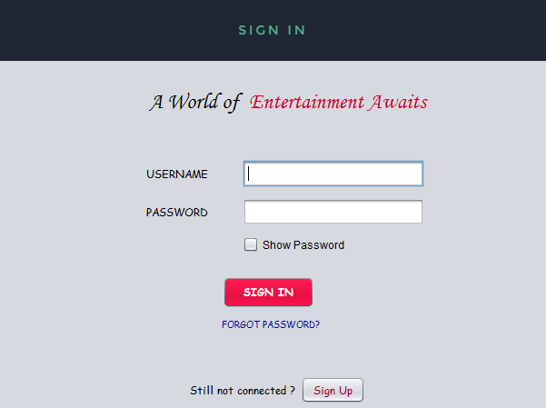

Fig 9.2 User Login page

* **Movies :**

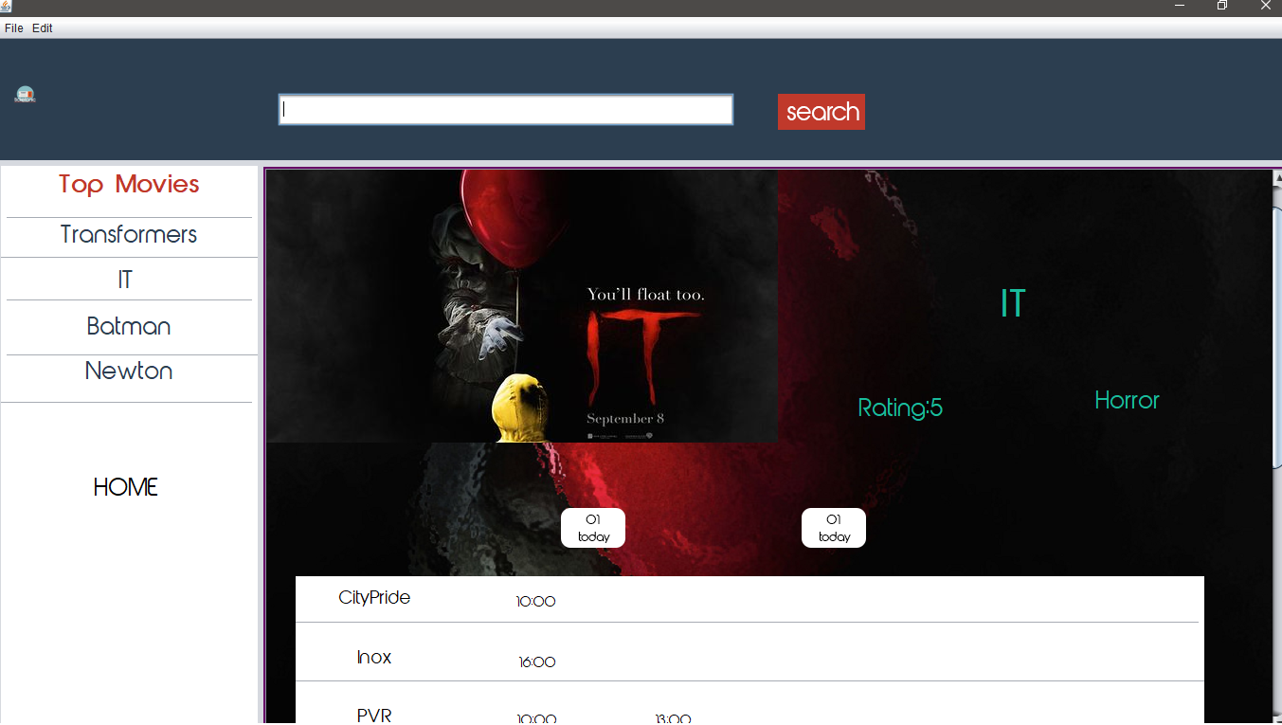

Fig 9.3 Movie page

* **No. of Seats selection frame :**

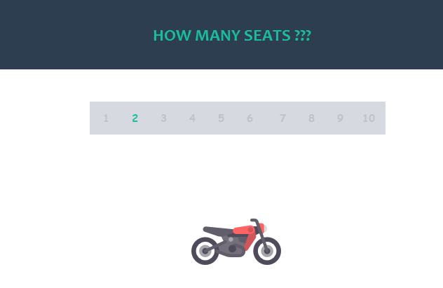

Fig 9.4 No. of seat selection page

* **Seat Selection Frame :**

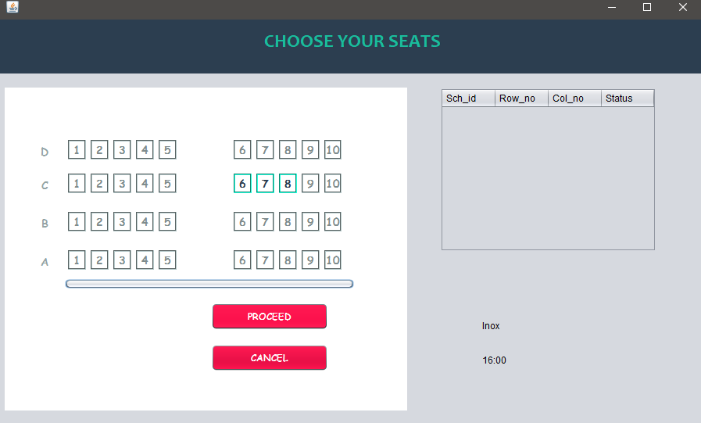

Fig 9.5 Seat selection page

* **Payment :**

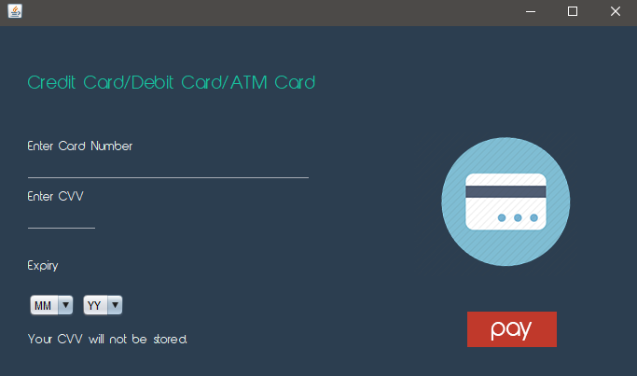

Fig 9.6 Payment page

* **Admin Signin Frame :**

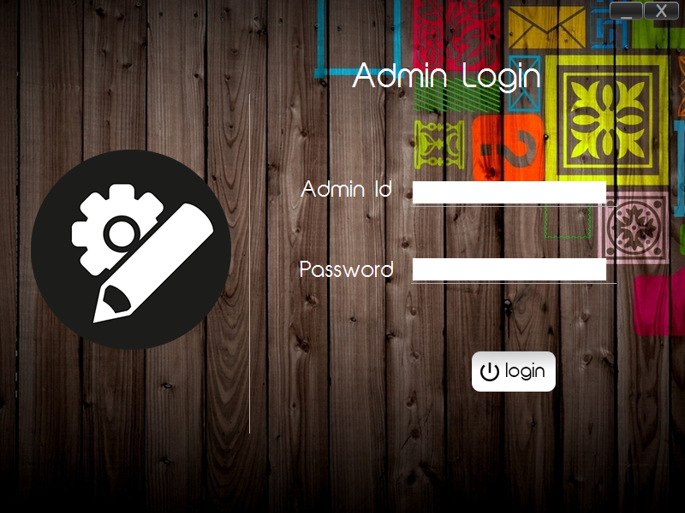

Fig 9.7 Admin Login page

* **Admin Management Frame :**

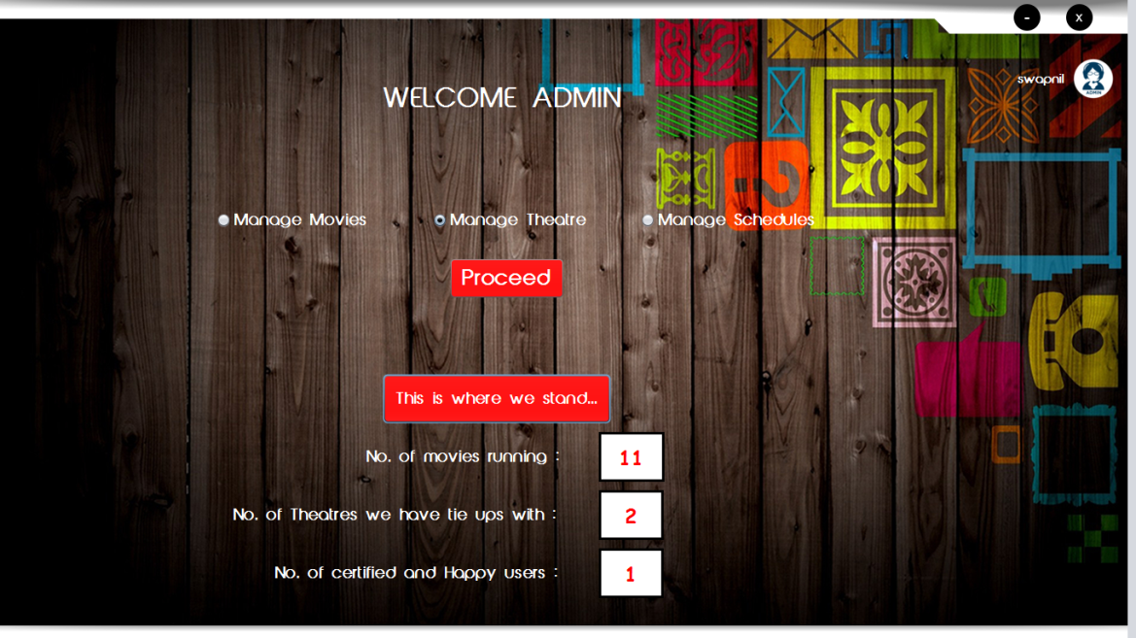

Fig 9.8 Admin homepage

**Chapter - 10**

**SAMPLE CODE**

**MySQL Connectivity Code:**

package logintrial;

import java.sql.Connection;

import java.sql.DriverManager;

public class mysqlconnector

{

public Connection getConnection() throws Exception

{

Connection con=null;

Class.forName("com.mysql.jdbc.Driver");

con=DriverManager.getConnection("jdbc:mysql://localhost:3306/project","root","mysql");

return con;

}

}

**User Login Code:**

private void btnSigninActionPerformed(java.awt.event.ActionEvent evt) {

mysqlconnector msq=new mysqlconnector();

try

{

Connection con = msq.getConnection();

PreparedStatement pst=con.prepareStatement("select * from user where user_name = ? and user_pwd = ?;");

//pst = con.prepareStatement(msq);

pst.setString(1, user_name.getText());

pst.setString(2,String.valueOf(user_pwd.getPassword()));

//ResultSet rs = null;

ResultSet rs = pst.executeQuery();

if (rs.next())

{

JOptionPane.showMessageDialog(this, "Logged in Successfully", "Info", JOptionPane.INFORMATION_MESSAGE);

}

else

{

JOptionPane.showMessageDialog(this, "Invalid Username/Password", "Info", JOptionPane.INFORMATION_MESSAGE);

}

}

catch (Exception e)

{

JOptionPane.showMessageDialog(null, e);

}

}

**Chapter - 11**

**CONCLUSION**

Nowadays, traditional reservation ways of movie ticketing is dying. It’s new age where technology dominates human life. With the software and technological devices, exceptions are reduced and even terminated. Also, people prefer easy, quick and safe way for every part of their life. This project is designed to meet the requirements of a movie ticket booking system. It has been developed in Java (JDK) and the database has been built in My SQL server keeping in mind the specifications of the system.

In our project with this movie ticketing system, movie production team as well as theatres can satisfy comfortable facilities to their customers. The relationship between cinema manager, employee, and customer satisfy a good communication to complete ticketing process. With this platform we developed, we are hoping to reduce time wasting, avoid misunderstandings, provide easy data flow, customer pleasure, and less hard work. We believe that we have accomplished our goals and satisfied with the code we developed.

**Chapter - 12**

**REFERENCES**

* Elmasri and Navathe, “Fundamentals of Database Systems” , 3/e, Addison - Wesley, 2001
* A Silberschaltz, H.F. Korth, and S sudarshan, “Database System Concepts”, 3/e, Tata Mcgraw Hill,1997
* Thomas M. Connolly, Carolyn E. Begg, “Database Systems & Practical Approach to Design Implementation and Management”, 4/e, Addison – Wesley, 2005
* “Zetcode” - zetcode.com/db/mysqljava
* “Stack Overflow” - stackoverflow.com